***PAAREES PERFUMES***

***VERSACE***

***FOR UNISEX***

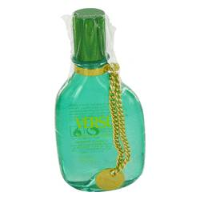

# 

# *Time To Relax*

## *Description:*

Time to Relax by Versace Perfume. Introduced in the year 2002, by the design house of Versace. Time to Relax is a relaxing fragrance with blend of kava-kava, soft fruits, fressia, amber and cedar wood. It is recommended for casual wear.